[root@localhost ~]# setenforce 0

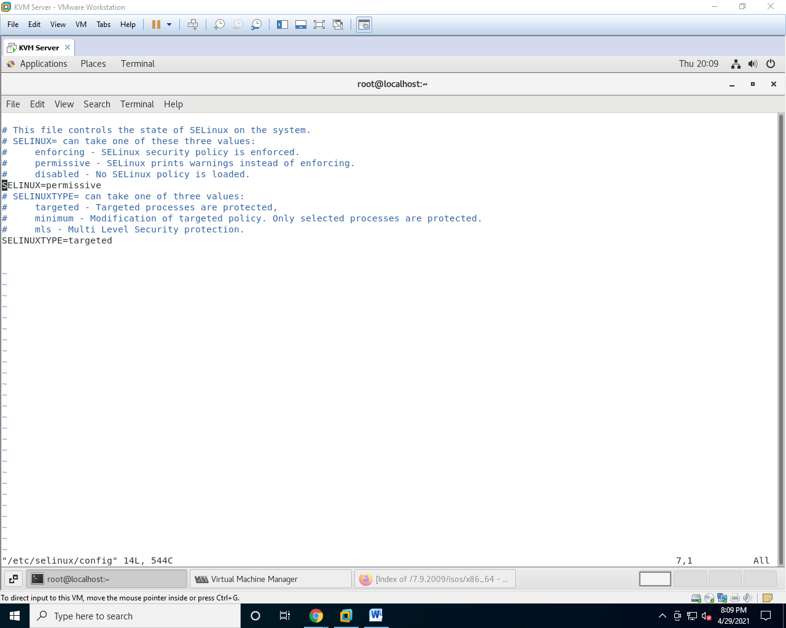[root@localhost ~]# vim /etc/selinux/config

[root@localhost ~]# yum install qemu-kvm qemu-img

Loaded plugins: fastestmirror, langpacks

Loading mirror speeds from cached hostfile

* base: centos.excellmedia.net

* extras: centos.excellmedia.net

* updates: centos.excellmedia.net

Package 10:qemu-kvm-1.5.3-175.el7_9.3.x86_64 already installed and latest version

Package 10:qemu-img-1.5.3-175.el7_9.3.x86_64 already installed and latest version

Nothing to do

[root@localhost ~]# yum install virt-manager libvirt libvirt-python libvirt-client -y

Loaded plugins: fastestmirror, langpacks

Loading mirror speeds from cached hostfile

* base: centos.excellmedia.net

* extras: centos.excellmedia.net

* updates: centos.excellmedia.net

Resolving Dependencies

--> Running transaction check

---> Package libvirt.x86_64 0:4.5.0-36.el7_9.3 will be installed

--> Processing Dependency: libvirt-daemon-driver-lxc = 4.5.0-36.el7_9.3 for package: libvirt-4.5.0-36.el7_9.3.x86_64

--> Processing Dependency: libvirt-daemon-config-nwfilter = 4.5.0-36.el7_9.3 for package: libvirt-4.5.0-36.el7_9.3.x86_64

---> Package libvirt-client.x86_64 0:4.5.0-36.el7_9.3 will be installed

--> Processing Dependency: libvirt-bash-completion = 4.5.0-36.el7_9.3 for package: libvirt-client-4.5.0-36.el7_9.3.x86_64

--> Processing Dependency: gnutls-utils for package: libvirt-client-4.5.0-36.el7_9.3.x86_64

---> Package libvirt-python.x86_64 0:4.5.0-1.el7 will be installed

---> Package virt-manager.noarch 0:1.5.0-7.el7 will be installed

